Software Design Specification
NIC College Ambassador Program Portfolio
Backend-Focused System Design

Document Status: Draft – for internal review
Version 0.1
1 July 2026
Prepared for: National Innovation Centre (NIC), Nepal – College Ambassador Program
Traces to: SRS – NIC College Ambassador Program Portfolio, Draft v0.1 (25 June 2026)

Document Control

Revision History
Version | Date | Description | Author
0.1 | 1 Jul 2026 | Initial draft – Software Design Specification derived from approved SRS v0.1 | Engineering Team

Related Documents
- Software Requirements Specification (SRS) – NIC College Ambassador Program Portfolio, Draft v0.1, 25 June 2026

Table of Contents

1. Introduction

1.1 Purpose
This Software Design Specification (SDS) translates the approved Software Requirements Specification (SRS) for the NIC College Ambassador Program Portfolio into a concrete technical design: system architecture, module decomposition, database schema, API design, workflow logic, and deployment topology. It is written for the engineering team – primarily backend engineers – who will implement, test, and deploy the system, and it assumes no prior context beyond the SRS.

1.2 Scope
This document covers the design of the public website, the ambassador self-service dashboard, the administrative console, and the backend services that support recruitment, ambassador content verification, event management, and content publishing. It does not cover UI visual design (colors, typography beyond the brand palette already fixed in the SRS) or infrastructure procurement/costing, which are addressed separately.

1.3 Key Design Decision – Verified Content Model
The SRS describes an Ambassador Dashboard where ambassadors manage their own profile and report activities. This design introduces one binding architectural rule that shapes the entire backend:
- Nothing an ambassador submits or edits – profile fields, skills, projects, achievements, or activity reports – is written directly to a publicly or administratively visible record.
- Every such submission is stored as a pending change request, isolated from the “live” published record.
- An administrator must explicitly review and approve a change before it is merged into the published profile, the Ambassador Network directory, or any report used in analytics.
- Rejected changes never touch the published record; the ambassador is notified with the reason and may revise and resubmit.
This is implemented as a moderation queue pattern (Section 3.3, Section 7) rather than a simple CRUD-with-flag pattern, specifically so that unverified data can never leak into a public or admin-facing “trusted” view through a missed status filter. Sections 4, 6, and 7 show how this is enforced at the data-model, data-flow, and workflow level.
Note on divergence from the SRS: SRS §4.2 originally specified Google OAuth as the authentication mechanism. Following a subsequent design decision, this SDS instead specifies system-issued organization email + password credentials, generated automatically when an application is approved (Section 3.1). The SRS should be updated to reflect this before the next review cycle so the two documents stay in sync.

1.4 Definitions, Acronyms, and Abbreviations
Term | Meaning
SDS | Software Design Specification (this document)
SRS | Software Requirements Specification (the source requirements document)
DRF | Django REST Framework
ERD | Entity-Relationship Diagram
DFD | Data Flow Diagram
JWT | JSON Web Token
RBAC | Role-Based Access Control
Pending record | A change submitted by an ambassador, not yet reviewed by an admin
Published record | The verified, publicly/administratively visible version of a record

1.5 Document Overview
Section 2 defines the system architecture and technology stack. Section 3 details backend module design. Section 4 defines the database design and ER diagram. Section 5 presents the use case model. Section 6 presents data flow diagrams. Section 7 details the verification workflow design in depth. Section 8 defines the API design. Section 9 defines the deployment architecture. Section 10 covers non-functional design. Section 11 provides a requirements traceability matrix.

2. System Architecture

2.1 Architectural Style
The system is designed as a layered, service-oriented REST architecture: independent single-page-application (SPA) frontends consume a Django REST Framework (DRF) backend exposed as a single versioned JSON API. The backend is organized into cohesive domain services (modules) within one Django project – a “modular monolith” – which keeps operational complexity low while preserving clean internal boundaries that could later be split into separate services if scale demands it.
- Three frontend applications share one API: the public website, the ambassador dashboard, and the admin console. This lets each be deployed, cached, and access-controlled independently.
- The backend is stateless per request (session/JWT carried by the client), enabling horizontal scaling of application servers behind a load balancer.
- Asynchronous work (emails, notifications) is offloaded to a task queue so request/response cycles stay fast.

2.2 High-Level Architecture Diagram
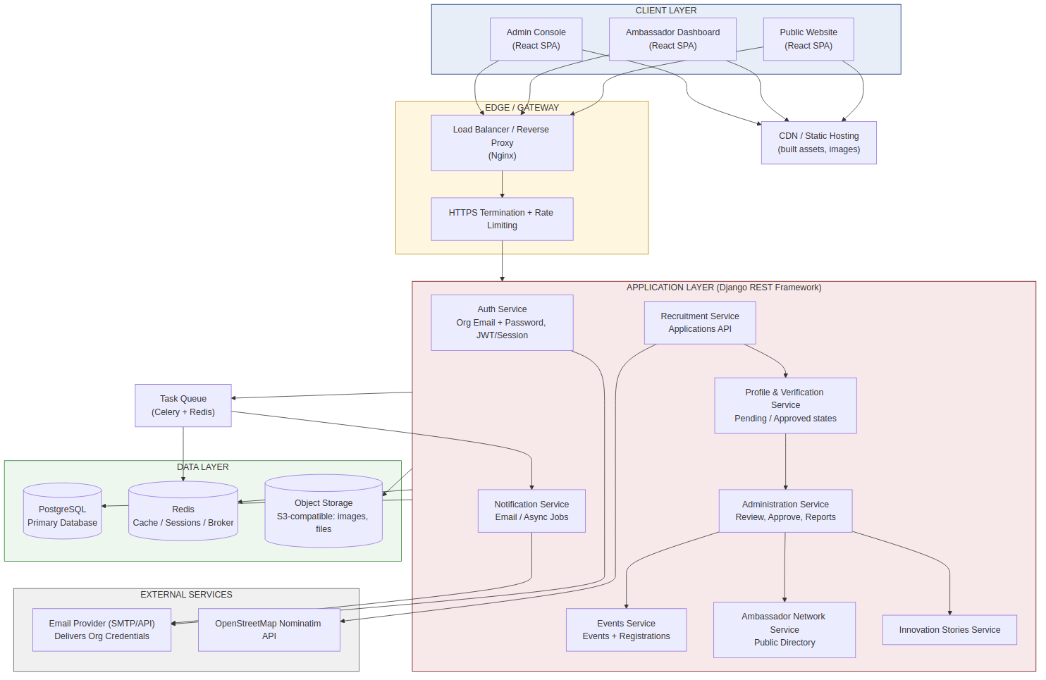
Figure 2.1 – High-level system architecture

2.3 Component Responsibilities
Component | Responsibility
Public Website | Renders homepage, program info, event listings, innovation stories, ambassador directory, and the application form. Read-mostly; only calls write endpoints for applications.
Ambassador Dashboard | Authenticated SPA for ambassadors to view status, edit profile, submit activity reports, and register for events. All writes go through the verification service.
Admin Console | Authenticated SPA for NIC staff to review applications, review pending profile/report changes, manage events, publish stories, and view analytics.
Auth Service | Issues and verifies organization email + password credentials, enforces password policy and forced first-login change, and resolves the caller's role (Visitor, Ambassador, Administrator).
Recruitment Service | Accepts and validates applications, routes them to admins, and provisions an Ambassador account on approval.
Profile & Verification Service | Central moderation engine. Accepts ambassador-submitted changes as pending requests; exposes admin review/approve/reject actions; merges approved data into published records.
Events Service | Manages event CRUD, registrations, and the upcoming/past event archive.
Ambassador Network Service | Serves the public ambassador directory, reading only from published profile data.
Innovation Stories Service | Admin-authored/published content pipeline for showcasing projects.
Administration Service | Aggregates records, application/report/change queues, and analytics for the admin console.
Notification Service | Sends email notifications (submission received, approved, rejected) via an async task queue.

2.4 Technology Stack
Layer | Technology | Rationale
Frontend | React (SPA), fetch/axios against JSON API | Matches SRS UI requirements; component reuse across the three frontends
Backend framework | Django + Django REST Framework | Specified in SRS §4.2; batteries-included ORM, admin, auth, and serializer validation
Database | PostgreSQL | Specified in SRS §4.2; strong relational integrity for the moderation workflow
Cache / broker | Redis | Session cache and Celery message broker
Async tasks | Celery + Celery Beat | Email notifications, scheduled digest of pending items, report generation
Auth | Django auth (Argon2 password hashing) + JWT (SimpleJWT) or session auth | Organization-issued email + password login; no third-party identity provider dependency
Object storage | S3-compatible bucket | Profile photos, event photos, recommendation letters
Geocoding | OpenStreetMap Nominatim API | College/institution location lookup (OSM per SRS Table 1)
Web server | Nginx + Gunicorn | TLS termination, reverse proxy, WSGI application server
CI/CD | Git + hosted CI (e.g. GitHub Actions) + container registry | Automated build, test, and deploy pipeline (Section 9.3)

3. Detailed Backend Module Design
Each module below is a Django app with its own models, serializers, views/viewsets, permissions, and tests. All endpoints are prefixed /api/v1/.

3.1 Auth Module (accounts)
Responsibilities: organization-credential issuance on approval, login/logout, password lifecycle, token issuance/refresh, and role resolution. There is no third-party identity provider in this design – the system is the sole source of truth for ambassador and admin credentials, so this module is also where password security controls live.
Endpoint | Method | Access | Purpose
/auth/login | POST | Public | Authenticate with organization_email + password; returns access/refresh token or session
/auth/token/refresh | POST | Authenticated | Refresh access token
/auth/logout | POST | Authenticated | Invalidate refresh token / session
/auth/password/change | POST | Authenticated | Set a new password; required before dashboard access if must_change_password is true
/auth/password/forgot | POST | Public | Request a password reset link sent to the organization email
/auth/password/reset | POST | Public (with valid reset token) | Complete a password reset using the emailed token
/auth/me | GET | Authenticated | Return current user, role, and linked ambassador/admin profile id
Account provisioning – this is the only path that creates login credentials:
- Anyone may submit an application through the public site (SRS FR-2.1); no account or login is required to apply.
- When an administrator approves an application (Section 3.2), the Auth module auto-generates an organization email address for the ambassador (e.g. firstname.lastname@<org-domain>) and a one-time temporary password.
- The temporary password is never shown in the admin UI or logged in plaintext; it exists only in the outbound email and as a hash in the database.
- must_change_password is set to true on the new USER record, so the very first login forces a password change before the dashboard becomes accessible.
- Passwords are hashed with Argon2 (Django's recommended hasher); the system never stores or emails a password after the initial provisioning message.

3.1.1 Account Provisioning &amp; First Login – Sequence
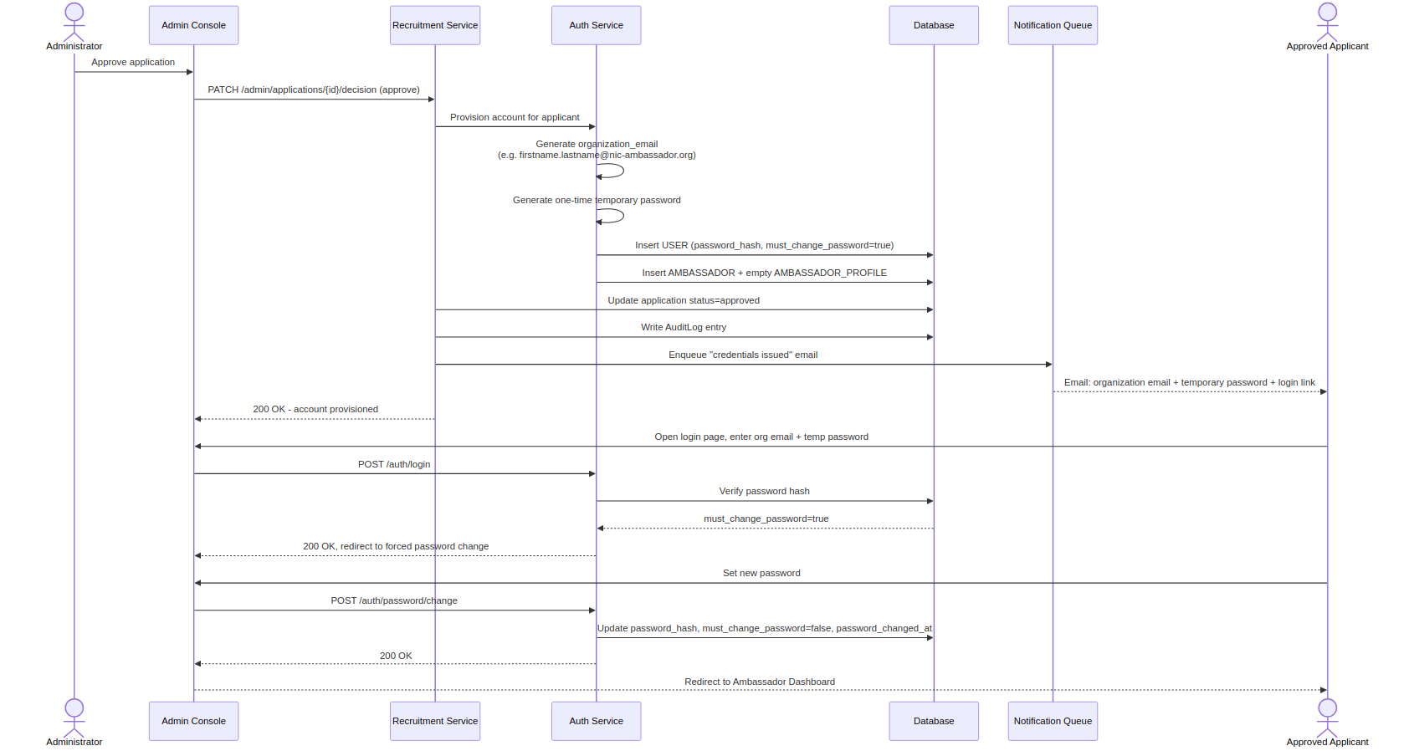
Figure 3.1 – Sequence diagram: credential issuance and forced first login

3.1.2 Password Policy
- Minimum 10 characters, checked against a common-password blocklist; no maximum-complexity gimmicks that encourage predictable substitutions.
- Temporary passwords are randomly generated (not derived from the applicant's name or email) and expire if unused after a configurable window (e.g. 7 days), after which the ambassador must use the forgot-password flow.
- Rate limiting on /auth/login and /auth/password/forgot to slow credential-stuffing and enumeration attempts.
- Failed login attempts are tracked per account with temporary lockout after a threshold, logged to AUDIT_LOG.

3.2 Recruitment Module (applications)
Responsibilities: implements FR-2.1 to FR-2.4 – application intake, validation, admin decisioning, and account provisioning.
Endpoint | Method | Access | Purpose
/applications | POST | Public | Submit application (Table 1 fields); server-side validation of all required fields
/applications/{id} | GET | Public (owner by email token) / Admin | Check application status
/admin/applications | GET | Admin | List/filter applications by status
/admin/applications/{id}/decision | PATCH | Admin | Approve (provisions Ambassador + User) or reject with notes
- Business rule: approving an application is the only path that creates a USER + AMBASSADOR pair. Approval triggers the Auth module's provisioning flow (Section 3.1.1), which issues the organization email/password credentials, and creates an empty AMBASSADOR_PROFILE (published) with no content yet, so the profile-completion flow (3.3) has a record to attach pending changes to.

3.3 Profile & Verification Module (verification) – core module
Responsibilities: implements the moderation queue described in Section 1.3 for ambassador profile fields and activity reports. This module is the single write-path enforcement point – no other module is permitted to write to AMBASSADOR_PROFILE directly.
Endpoint | Method | Access | Purpose
/me/profile/change-requests | POST | Ambassador | Submit a proposed change (bio, skills, project, achievement, photo, LinkedIn)
/me/profile/change-requests | GET | Ambassador | List own pending/approved/rejected change requests
/me/reports | POST | Ambassador | Submit an activity report (also enters pending state)
/me/reports | GET | Ambassador | List own reports and their status
/admin/change-requests | GET | Admin | List pending (default) / all change requests, filterable by ambassador, section, status
/admin/change-requests/{id}/approve | PATCH | Admin | Approve: merges proposed_data into AMBASSADOR_PROFILE, sets status=approved, writes audit log
/admin/change-requests/{id}/reject | PATCH | Admin | Reject with required review_notes; status=rejected
/admin/reports | GET | Admin | List pending/approved/rejected activity reports
/admin/reports/{id}/approve | PATCH | Admin | Approve report so it counts toward dashboard stats and analytics
/admin/reports/{id}/reject | PATCH | Admin | Reject report with notes
Design rules enforced in this module (see Section 7 for full workflow):
- A change request stores proposed_data as a JSON diff scoped to one section (profile bio, skills, a single project, a single achievement) so partial approvals are possible without blocking unrelated edits.
- AMBASSADOR_PROFILE (the published table) is only ever written by the approve action, inside a database transaction, together with the AUDIT_LOG insert – never from the ambassador-facing serializer.
- The ambassador dashboard summary (FR-3.1) and the public Ambassador Network directory (FR-4.1) read exclusively from AMBASSADOR_PROFILE, never from PROFILE_CHANGE_REQUEST, so pending/unapproved content is structurally unreachable from those views.
- Every approve/reject action is authorization-checked (admin role) and logged to AUDIT_LOG with actor, before/after snapshot reference, and timestamp.

3.4 Events Module (events)
Endpoint | Method | Access | Purpose
/events | GET | Public | List upcoming/past events (FR-5.1, FR-5.2)
/events/{id} | GET | Public | Event detail including photos/report archive
/events/{id}/register | POST | Ambassador | Register for an upcoming event
/admin/events | POST/PUT/DELETE | Admin | Create, edit, remove events (FR-7.3)

3.5 Ambassador Network Module (network)
Endpoint | Method | Access | Purpose
/ambassadors | GET | Public | Directory: name, college, location, LinkedIn, skills, achievements (FR-4.1) – published data only
/ambassadors/{id} | GET | Public | Public ambassador profile detail

3.6 Innovation Stories Module (stories)
Endpoint | Method | Access | Purpose
/stories | GET | Public | List published innovation stories (FR-6.1)
/admin/stories | POST/PUT/DELETE | Admin | Author and publish stories

3.7 Administration Module (admin_dashboard)
Endpoint | Method | Access | Purpose
/admin/ambassadors | GET/PATCH | Admin | View, edit, deactivate ambassador records (FR-7.1)
/admin/analytics | GET | Admin | Counts: ambassadors, applications, events, pending queue sizes (FR-7.4)

3.8 Notification Module (notifications)
A Celery-based async module triggered by domain events (application submitted, change request created, change approved/rejected, report approved/rejected, event created). Templated emails are queued rather than sent inline so API responses stay fast and a mail-provider outage cannot fail a user-facing request.

4. Database Design

4.1 Entity-Relationship Diagram
The schema below directly encodes the verification rule from Section 1.3: AMBASSADOR_PROFILE (published) and PROFILE_CHANGE_REQUEST / ACTIVITY_REPORT (pending review) are separate tables, connected only through the approval action in the Verification module. No foreign key or view allows a pending record to be read as if it were published.
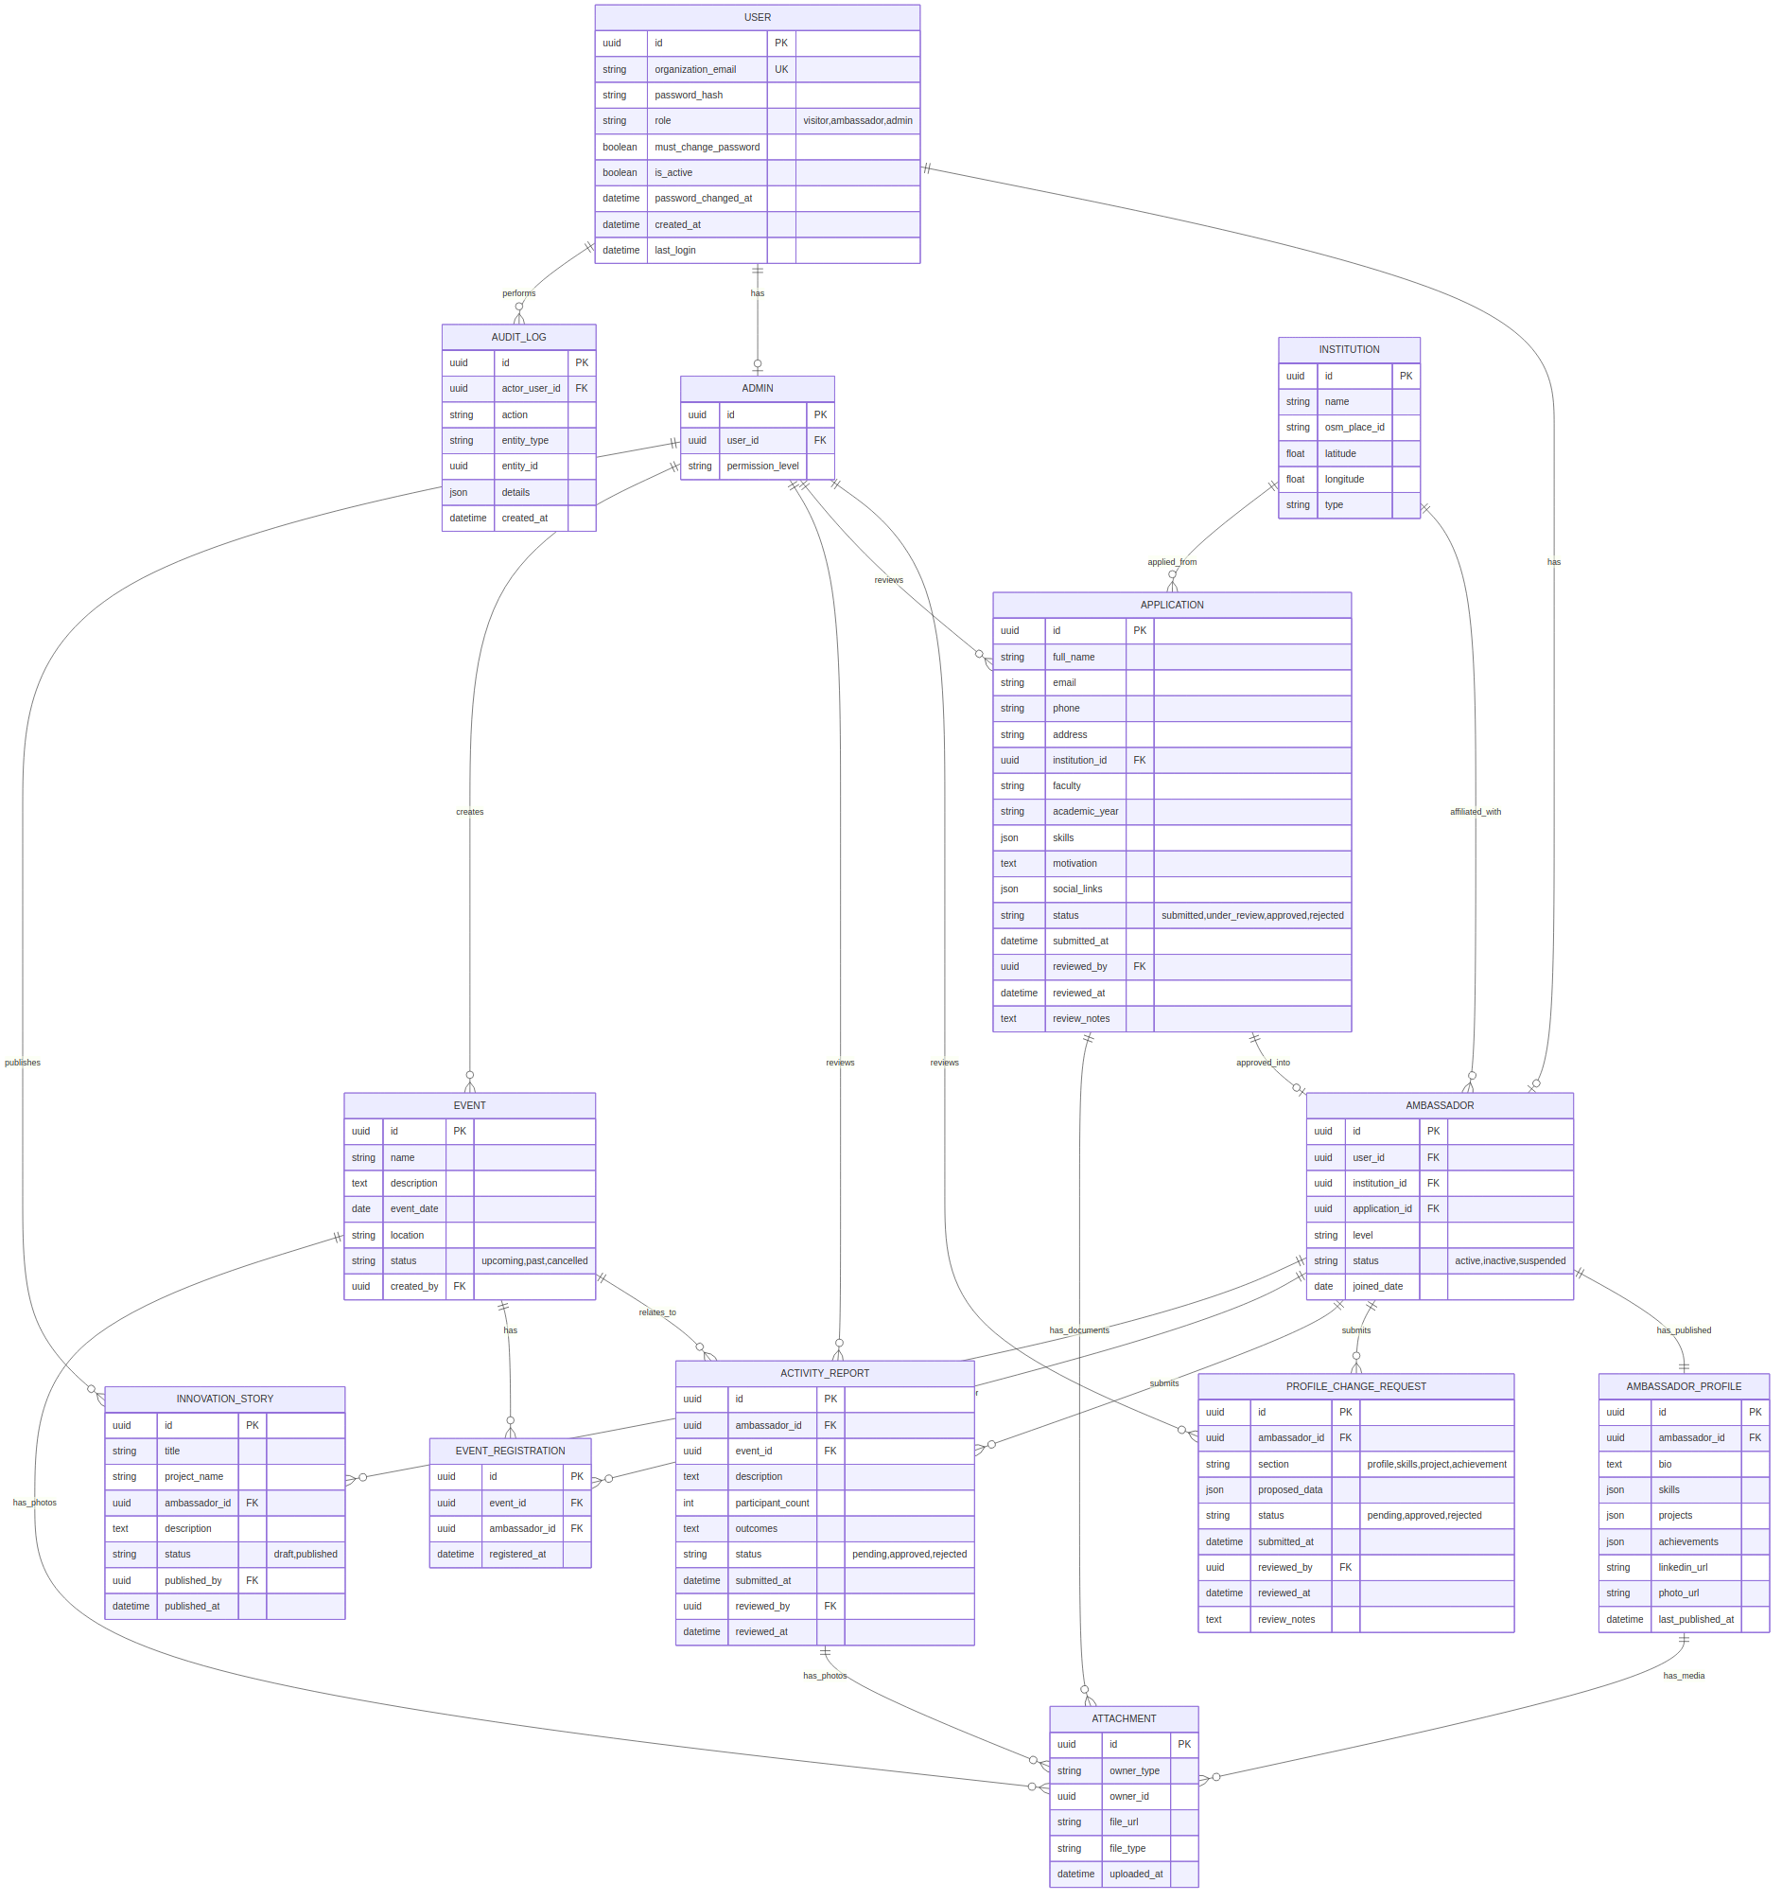
Figure 4.1 – Entity-Relationship Diagram

4.2 Key Entity Descriptions

USER
Central identity record. Created only when an application is approved (for ambassadors) or provisioned directly by a super-admin (for administrators). role determines which frontend/permissions apply; organization_email and password_hash are the sole login credential.

APPLICATION
One row per submission of the recruitment form (Table 1 of the SRS). status moves submitted → under_review → approved/rejected. Approval is the only trigger that creates an AMBASSADOR + USER pair for the applicant.

AMBASSADOR / AMBASSADOR_PROFILE
AMBASSADOR is the account/membership record (level, status, joined_date). AMBASSADOR_PROFILE is the single published, publicly-readable content record (bio, skills, projects, achievements, links, photo). It is a 1:1 child of AMBASSADOR and is only ever mutated by the approval action described in 3.3.

PROFILE_CHANGE_REQUEST
One row per proposed edit, scoped to a section, holding proposed_data as JSON and a status lifecycle (pending → approved/rejected). This table is never read by public-facing or dashboard-summary endpoints – only by the ambassador who owns it and by admins.

ACTIVITY_REPORT
Ambassador-submitted event report; carries its own pending/approved/rejected lifecycle independent of PROFILE_CHANGE_REQUEST because reports have different review criteria (participant counts, outcomes) than profile content.

EVENT / EVENT_REGISTRATION
Standard event catalog and many-to-many registration join table between AMBASSADOR and EVENT.

INNOVATION_STORY
Admin-authored content; draft/published lifecycle, optionally attributed to an ambassador.

ATTACHMENT
Polymorphic file reference (owner_type/owner_id) used for profile photos, activity report photos, recommendation letters, and event photos, all stored in object storage with only the URL persisted in PostgreSQL.

AUDIT_LOG
Immutable append-only log of every state-changing admin action (approve/reject/publish/deactivate), required for accountability over the verification workflow and for NFR-2 (security).

4.3 Normalization and Integrity
- Schema is normalized to 3NF; JSON columns (skills, proposed_data, social_links) are used only for genuinely variable/semi-structured data, not to avoid relational modeling.
- Foreign keys enforce referential integrity; PROFILE_CHANGE_REQUEST.ambassador_id and ACTIVITY_REPORT.ambassador_id cascade-restrict on delete to preserve audit history.
- Status fields are constrained with database-level CHECK constraints (or Django choices + migration-level constraints) so invalid states cannot be written even by a direct DB script.

4.4 Indexing Strategy
Table | Index | Reason
PROFILE_CHANGE_REQUEST | (status, submitted_at) | Fast admin pending-queue listing, oldest-first
ACTIVITY_REPORT | (status, submitted_at) | Fast admin pending-queue listing
AMBASSADOR_PROFILE | (ambassador_id) unique | Enforce 1:1 with AMBASSADOR, fast lookup
EVENT | (event_date, status) | Upcoming/past filtering
APPLICATION | (status, submitted_at) | Admin review queue
AUDIT_LOG | (entity_type, entity_id) | Fast “history for this record” lookups

5. Use Case Model

5.1 Actors
Actor | Description
Visitor | Any public user browsing the site or submitting an application (unauthenticated)
Ambassador | Approved student representative, authenticated with an organization-issued email and password
Administrator | NIC staff member with review and management permissions

5.2 Use Case Diagram
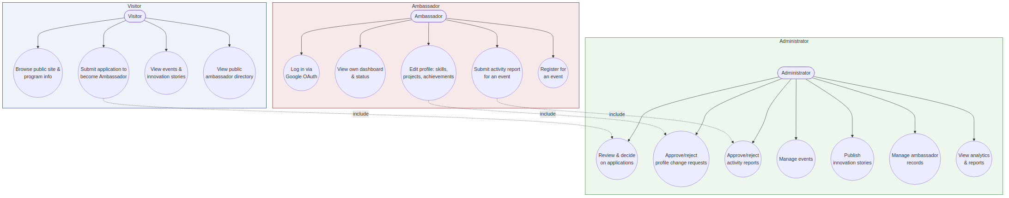
Figure 5.1 – Use case diagram by actor

5.3 Detailed Use Case: Submit Profile Change
Field | Description
Actor | Ambassador
Precondition | Ambassador is authenticated and has an active AMBASSADOR record
Trigger | Ambassador edits a profile field, skill, project, or achievement in the dashboard
Main flow | 1. Ambassador edits a field. 2. Frontend submits a PROFILE_CHANGE_REQUEST. 3. System stores it as pending and confirms receipt. 4. Published profile is unchanged. 5. Admin is notified.
Postcondition | A pending change request exists; the public/dashboard-summary view is unaffected until reviewed
Alternate flow | Ambassador has an existing pending request for the same section – system may allow superseding the earlier pending draft rather than creating a duplicate

5.4 Detailed Use Case: Review and Approve/Reject Change
Field | Description
Actor | Administrator
Precondition | Administrator is authenticated; at least one pending change request or report exists
Trigger | Administrator opens the pending queue in the Admin Console
Main flow | 1. Admin views a pending item and its proposed data. 2. Admin approves (system merges data into the published record and logs the action) or rejects with notes. 3. Ambassador is notified of the outcome.
Postcondition | On approval: published record reflects the change and is now visible on public/dashboard views. On rejection: published record is untouched; ambassador can revise and resubmit.
Exception flow | Concurrent edit: if the ambassador submits a new change to the same section while one is pending, the system flags it for the admin rather than silently overwriting the earlier pending request.

6. Data Flow Diagrams

6.1 Level 0 – Context Diagram
The system is treated as a single process exchanging data with four external entities, matching the SRS user classes.
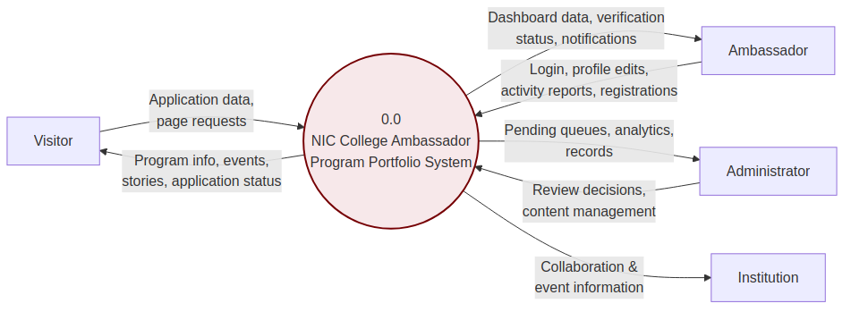
Figure 6.1 – DFD Level 0 (Context Diagram)

6.2 Level 1 – Process Decomposition
The Level 1 diagram decomposes the system into its five major processes and shows the data stores each one touches. Note that Process 2.0 (Profile & Content Verification) is the only process permitted to write to D4 (Published Profiles); Process 4.0 (Public Content Delivery) only ever reads from D4, D5, and D7 – it has no path to D3 or the pending side of D6, which is what structurally prevents unverified content from reaching the public site.
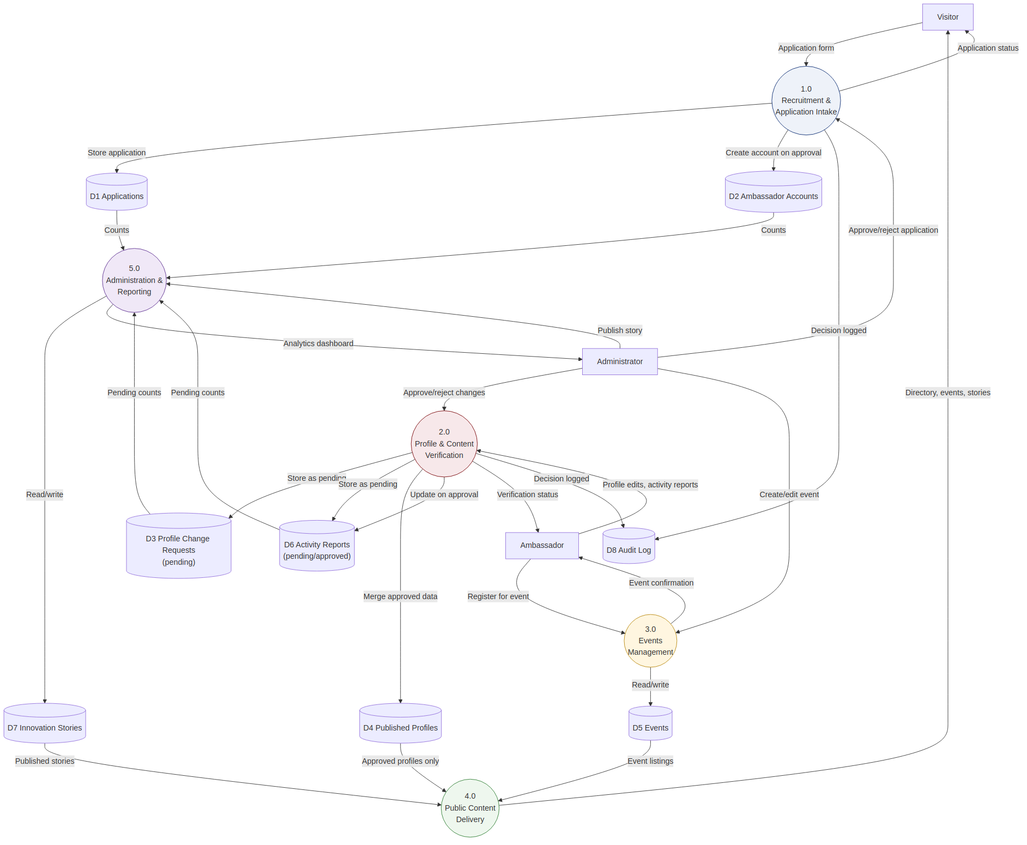
Figure 6.2 – DFD Level 1

6.3 Data Store Descriptions
Store | Contents | Written by | Read by
D1 Applications | Recruitment submissions | Process 1.0 | Process 1.0, 5.0
D2 Ambassador Accounts | AMBASSADOR + USER records | Process 1.0 | Process 2.0, 3.0, 5.0
D3 Profile Change Requests | Pending profile/skill/project/achievement edits | Process 2.0 | Process 2.0, 5.0
D4 Published Profiles | Verified AMBASSADOR_PROFILE content | Process 2.0 only | Process 4.0, 5.0
D5 Events | Event catalog and registrations | Process 3.0 | Process 3.0, 4.0, 5.0
D6 Activity Reports | Pending and approved reports | Process 2.0 | Process 2.0, 5.0
D7 Innovation Stories | Draft and published stories | Process 5.0 | Process 4.0
D8 Audit Log | Every admin decision | Process 1.0, 2.0 | Process 5.0

7. Verification &amp; Moderation Workflow Design
This section specifies, at implementation level, the workflow referenced throughout this document as the system's core differentiator: ambassador-submitted content is never directly visible until an administrator verifies it.

7.1 State Model
Every PROFILE_CHANGE_REQUEST and ACTIVITY_REPORT follows the same status state machine:
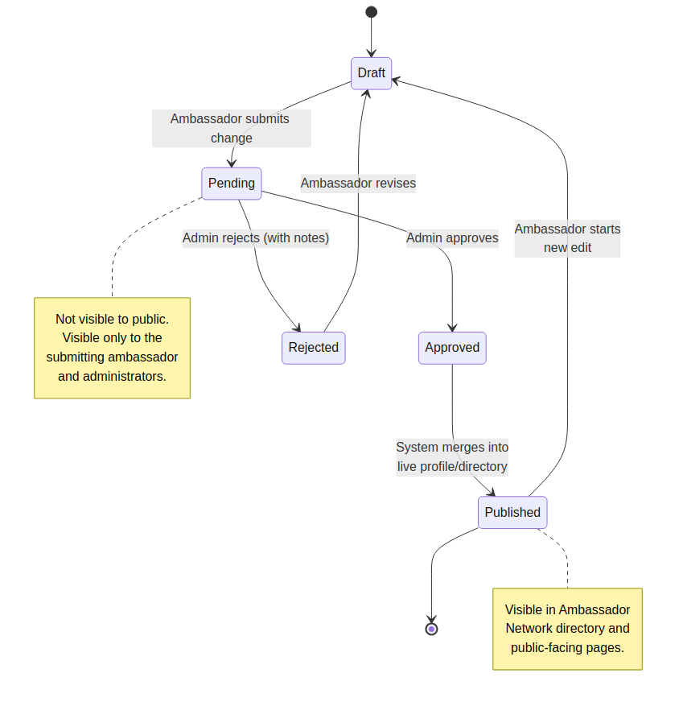
Figure 7.1 – Verification status state diagram

7.2 Sequence: Submit → Review → Publish/Reject
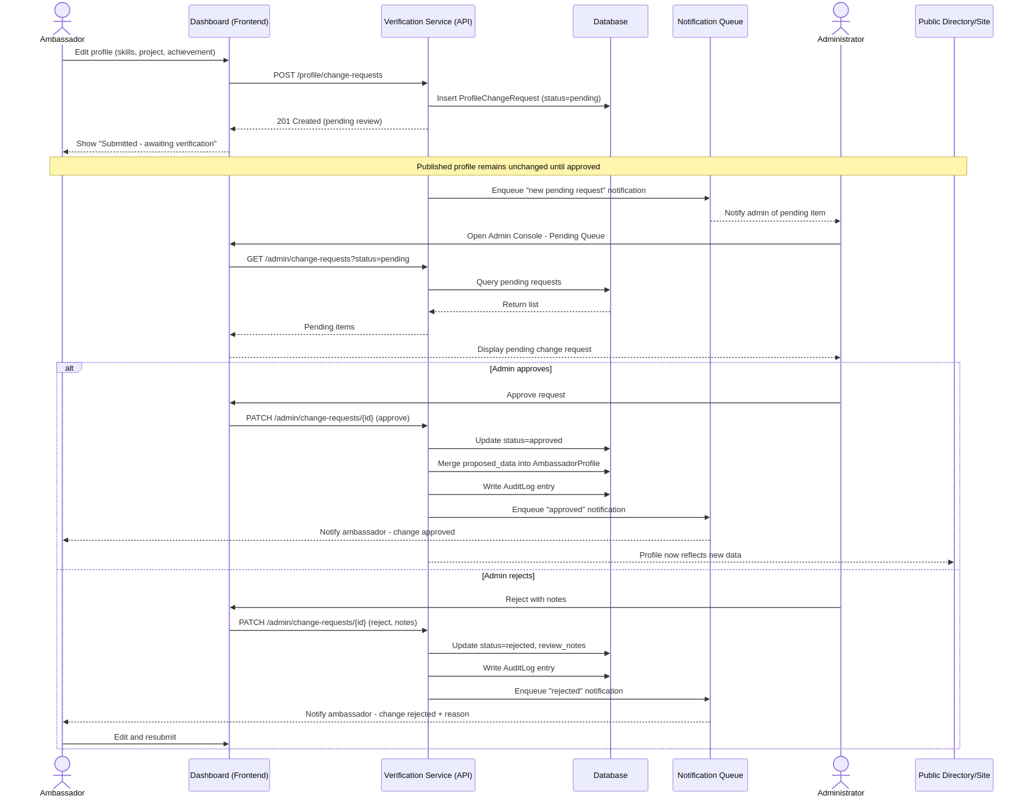
Figure 7.2 – Sequence diagram: profile change verification

7.3 Business Rules
- A change request is created with status=pending and is associated with exactly one ambassador and one content section.
- The published table (AMBASSADOR_PROFILE) is updated only inside the approve transaction, atomically with the AUDIT_LOG write, so a crash mid-approval cannot leave the system in an inconsistent state (either both happen or neither does).
- Rejection requires a non-empty review_notes value so the ambassador always receives actionable feedback.
- Ambassadors may only view and act on their own change requests; admins may view all. This is enforced by DRF permission classes, not just by frontend routing.
- All list/detail endpoints used by public pages and the dashboard summary query AMBASSADOR_PROFILE (or approved ACTIVITY_REPORT rows) directly – they never join through PROFILE_CHANGE_REQUEST regardless of its status, removing the possibility of a filter bug exposing pending content.
- A resubmission after rejection creates a new PROFILE_CHANGE_REQUEST row rather than mutating the rejected one, preserving full history in AUDIT_LOG and the change-request table itself.

7.4 Notifications Triggered by This Workflow
Event | Recipient | Channel
Change request submitted | Administrators (digest or immediate) | Email via Celery task
Change request approved | Submitting ambassador | Email via Celery task
Change request rejected | Submitting ambassador (with reason) | Email via Celery task
Activity report approved/rejected | Submitting ambassador | Email via Celery task

8. API Design

8.1 Conventions
- Base path: /api/v1/ – versioned so breaking changes can ship as /api/v2/ without disrupting existing clients.
- Resource-oriented URLs, plural nouns, standard HTTP verbs (GET/POST/PATCH/DELETE).
- All request/response bodies are JSON; file uploads (photos, recommendation letters) use multipart/form-data and return an ATTACHMENT reference.
- Pagination via limit/offset or cursor on all list endpoints; default page size 20.
- Filtering via query parameters, e.g. /admin/change-requests?status=pending&ambassador=<id>.

8.2 Authorization Model (RBAC)
Resource area | Visitor | Ambassador | Administrator
Public content (events, stories, directory) | Read | Read | Read
Applications | Create own | – | Read/Decide all
Own profile change requests | – | Create/Read own | Read all, Approve/Reject
Own activity reports | – | Create/Read own | Read all, Approve/Reject
Events (management) | – | Register only | Full CRUD
Innovation stories (authoring) | – | – | Full CRUD
Ambassador records | – | Read/Edit own account settings | Read/Edit/Deactivate all
Analytics | – | – | Read

8.3 Example Contract – Submit Profile Change
POST /api/v1/me/profile/change-requests
Request body:
{
"section": "skills",
"proposed_data": { "skills": ["UI/UX", "Public Speaking", "Python"] }
}
Response 201 Created:
{
"id": "6f2c...",
"ambassador_id": "a1b2...",
"section": "skills",
"status": "pending",
"submitted_at": "2026-07-01T09:15:00Z"
}

8.4 Error Handling
- Standard error envelope: { "error": { "code": "...", "message": "...", "fields": {...} } } for validation errors.
- 400 for validation errors (e.g. missing required application field per FR-2.2), 401 unauthenticated, 403 wrong role/ownership, 404 not found, 409 for conflicting concurrent pending edits, 422 for business-rule violations (e.g. rejecting without notes).

8.5 Versioning &amp; Deprecation
Backward-incompatible changes are introduced under a new version prefix; the previous version is supported for a defined deprecation window and documented in release notes.

9. Deployment Architecture

9.1 Deployment Diagram
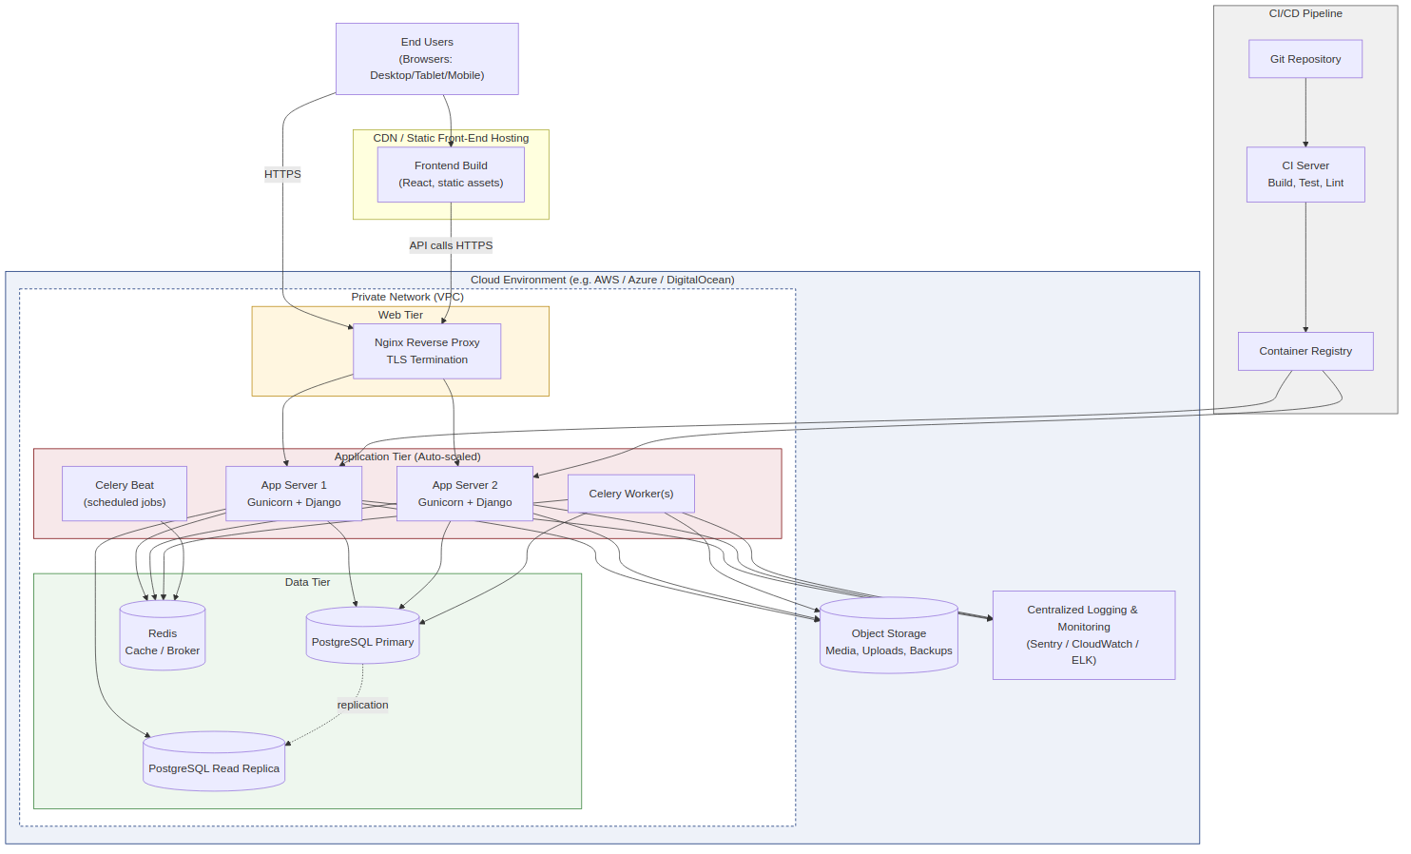
Figure 9.1 – Deployment architecture

9.2 Environments
Environment | Purpose | Notes
Development | Local/individual developer work | Docker Compose: Django, Postgres, Redis, Mailhog for email testing
Staging | Integration testing, NIC stakeholder review before release | Mirrors production topology at smaller scale; seeded with anonymized/test data
Production | Live system | Auto-scaled app tier, managed Postgres with automated backups, object storage, monitoring

9.3 CI/CD Pipeline
- Developer opens a pull request; CI runs linting, unit tests, and migration checks.
- On merge to main, CI builds a container image, runs the full test suite and a migration dry-run against a disposable database, then pushes the image to the registry.
- Deployment to staging is automatic on merge; deployment to production is a manual approval gate.
- Database migrations run as a pre-deploy step with a rollback plan documented per release.

9.4 Backup &amp; Disaster Recovery
- Automated daily PostgreSQL backups with point-in-time recovery retained for at least 30 days.
- Object storage (photos, documents) versioned and backed up separately from the database.
- AUDIT_LOG is included in backups and never purged, preserving a full history of verification decisions.

10. Non-Functional Design Considerations

10.1 Performance (NFR-1)
- Read-heavy public endpoints (directory, events, stories) are cached at the CDN/edge and in Redis with short TTLs, invalidated on admin publish actions.
- Images are resized/optimized on upload (server-side thumbnailing) before storage, addressing NFR-1.2.
- Database queries for list endpoints use select_related/prefetch_related to avoid N+1 queries; pending-queue queries are covered by the indexes in 4.4.

10.2 Security (NFR-2)
- All admin and ambassador endpoints require authentication (NFR-2.1); DRF permission classes enforce role-based access (NFR-2.2) at the view level, not just in the frontend.
- Because the system issues and stores its own credentials (Section 3.1) rather than delegating to a third-party identity provider, password hashing (Argon2), forced first-login password change, reset-token expiry, and login rate limiting are treated as core security requirements, not optional hardening.
- The verification workflow itself is a security control: it guarantees personal/professional data an ambassador submits is reviewed before exposure, directly supporting NFR-2.3 (secure handling of personal data).
- All traffic is served over HTTPS (CI-1); secrets and credentials are stored in a secrets manager, not in source control.
- File uploads (recommendation letters, photos) are validated for type/size and scanned before being made accessible.

10.3 Scalability (NFR-3)
- Stateless application servers scale horizontally behind the load balancer; the moderation queue design (small, indexed, status-filtered tables) keeps pending-queue queries fast as ambassador and report volume grows.
- Read replicas can absorb growth in public read traffic (directory, events, stories) independent of write load on the verification tables.

10.4 Maintainability (NFR-5)
- Modular Django app structure (Section 3) keeps each domain independently testable and lets administrators manage events/stories/resources without developer involvement, per NFR-5.1.
- OpenAPI schema generated from DRF serializers keeps API documentation in sync with code.

10.5 Usability &amp; Accessibility (NFR-4)
- Responsive layouts across desktop/tablet/mobile (UI-1); semantic HTML and ARIA labeling for accessibility; basic on-page SEO metadata for public pages (NFR-4.2).

11. Requirements Traceability Matrix
Maps key SRS functional requirements to the design elements that implement them.
SRS Requirement | Design Element(s)
FR-1.1 – FR-1.5 Public homepage content | Public Website frontend; Events, Network, Stories modules (§3.4–3.6)
FR-2.1 – FR-2.4 Application intake &amp; decision | Recruitment Module (§3.2); D1 Applications (§6.3)
FR-3.1 Dashboard summary | Profile &amp; Verification Module reading only published data (§3.3, §7.3 rule 5)
FR-3.2 Ambassador profile management | PROFILE_CHANGE_REQUEST + AMBASSADOR_PROFILE design (§4.2, §7)
FR-3.3 Activity report submission | ACTIVITY_REPORT verification lifecycle (§3.3, §7.1)
FR-4.1 Ambassador directory | Ambassador Network Module, reads D4 only (§3.5, §6.3)
FR-5.1 – FR-5.2 Events listing &amp; archive | Events Module (§3.4)
FR-6.1 Innovation stories | Innovation Stories Module (§3.6)
FR-7.1 – FR-7.4 Administration | Administration Module, Admin Console endpoints (§3.7, §8.2)
NFR-2.1 – NFR-2.3 Security | RBAC (§8.2), verification workflow (§7), HTTPS (§2.4, CI-1)

Appendix A: Glossary
Term | Meaning
Moderation queue | The set of pending PROFILE_CHANGE_REQUEST / ACTIVITY_REPORT rows awaiting admin decision
Published record | Data visible on public pages and dashboard summaries; only reachable via an approval action
Section (of a profile) | A scoped portion of profile content (bio, skills, one project, one achievement) submitted as an individual change request

Appendix B: Assumptions
- Content (initial text, images, event details) is supplied by NIC, consistent with SRS §2.4.
- Hosting, domain, and any paid third-party services (email provider, object storage) are arranged by NIC, consistent with SRS §2.4.
- Ambassador and administrator accounts are provisioned solely by the system on application approval / admin creation; there is no self-service registration and no third-party identity provider dependency (e.g. Google OAuth) for login.

